

**DEVELOPMENT OF A RENEWABLE ENERGY RESEARCH**

**WEB PORTAL: FINAL REPORT**

(March 12, 2009 – December 31, 2010)

SubmittedJanuary 3, 2011

**Charles C. Hinnant**, PhD <[chinnant@fsu.edu](mailto:chinnant@fsu.edu)>

Assistant Professor of Information Studies

**Ian Douglas**, PhD <[idouglas@ci.fsu.edu](mailto:idouglas@ci.fsu.edu)>

Associate Program Director, Learning Systems Institute and Associate Professor

**Charles R. McClure**, PhD <[cmcclure@lis.fsu.edu](mailto:cmcclure@lis.fsu.edu)>

Director, Information Institute and Francis Eppes Professor

With

**Bradley Wade Bishop**, PhD

Research Associate, Information Institute

**Nicole D. Alemanne**, MS

Doctoral Student and Research Associate, Information Institute

**Karen Doster,** MS

Research Associate, Information Institute

**Jiangna Han**, MS

Research Associate, Learning Systems Institute

**Mike Falcon**, MS, MBA

Webmaster, Information Institute

**Lauren H. Mandel**, MS

Doctoral Candidate and Research Coordinator, Information Institute

FOR

Dr. Dave Cartes, Director & David A. Pasquarelli, Chief of Staff

Institute for Energy Systems, Economics and Sustainability [www.ieses.fsu.edu](http://www.ieses.fsu.edu)

Florida State University

**DEVELOPMENT OF A RENEWABLE ENERGY RESEARCH**

**WEB PORTAL: FINAL REPORT**

In Spring 2009, the Information Use Management & Policy Institute (Information Institute) and the Learning Systems Institute (LSI) of Florida State University (FSU) began work on the grant entitled *Development of a Renewable Energy Research Web Portal*. The Institute for Energy Systems, Economics, and Sustainability (IESES) at FSU originally funded this grant at $219,000. However, the project funding was reduced to $194,542 after budget cuts. The project was granted on December 12, 2008 and planned to run for one year with an anticipated start date of February 20, 2009. Due to funding adjustments and an initial funding delay, an initial project report describing the activities that occurred between March 12, 2009 and September 15, 2009 was submitted to IESES on October 12, 2009. The project team submitted a second report to IESES on September 27, 2010 to communicate additional project activities. The project received two no-cost extensions that extended the final project deadline to December 31, 2010. This final report provides a summary of project activities performed from March 12, 2009 to December 31, 2010.

The project had the following three objectives:

1. Identify, organize, and make available via a web portal, research generated as part of the Florida Energy Systems Consortium (FESC) effort as well as other selected related information resources and tools as identified by FESC participants;
2. Provide IESES, FESC, policymakers, researchers, and others in the state of Florida with the research information they need to accomplish statewide energy goals and to help IESES meet the thirteen objectives it has undertaken by providing access to research information; and
3. Position the associated project team to seek additional external funding to continue and expand this/similar projects in the future.

**Project Description**

This project identified, organized, and made available via a web portal, research generated as part of the FESC effort as well as other selected related information resources and tools as identified by FESC participants. The goal of this project was to provide IESES, FESC, researchers, and others in the state of Florida with the research information they need to accomplish statewide energy goals. An initial product from this project was an operational web portal that identifies, organizes, and provides access to a range of FESC and other research related to renewable and alternative energy information. A second product was research results on extending technologies that allow users to share information and grow/sustain the web portal through a range of social networking techniques. This research attempts to position FSU to seek additional external funding related to interactive databases and web portals. The ultimate expected outcomes resulting from the project include increased IESES and FESC researcher productivity; increased leverage and collaboration of FESC resources and funding; and improved policy- and decision-making regarding the future uses and development of renewable and alternative energy in Florida.

**Summary of Activities**

The project team designed the study to include five tasks: 1) gather background information pertaining to renewable energy research, 2) conduct a needs assessment, 3) design and develop the renewable energy web portal, 4) evaluate the renewable energy web portal, and 5) disseminate and publicize the renewable energy web portal. In the first six months of the project the team completed the first task and began to work on tasks 2 and 3. Tasks 2 and 3 were completed and tasks 4 and 5 initiated by the project team during the next six-month period as the portal itself was developed and improved. During the no-cost extensions, the project team continued to refine the portal, evaluate its usage, and disseminate and publicize the portal to the renewable energy research community. Furthermore, the project team also attempted to explore additional means of pursuing funding opportunities from several research foundations, as well as government agencies. Table 1 lists the tasks that have been completed to date for each phase of the project.

Table 1. Summary of Completed Activities by Task

|  |  |
| --- | --- |
| **Tasks** | **Activities** |
| **Gather background**  **(3/12/09 to 5/27/09)** | Review and refine project tasking |
| Conduct literature review |
| Create sampling frame for survey and interviews |
| **Conduct needs**  **assessment**  **(5/28/09 to 12/31/2009)** | Develop data collection instruments |
| Survey deployment: recruitment letter mailed |
| Follow up emails requesting survey completion |
| Expert interviews conducted |
| **Design and develop**  **Web portal**  **(3/12/09 to 12/31/2010)** | Develop Beta versions of the portal and related applications |
| Collect data to populate the project database |
| Collect data to populate the event calendar |
| Collect content resources |
| Begin refinement of portal applications |
| **Evaluate Web Portal (1/1/2010 – 6/30/2010)** | Develop web analytics to track usage |
| Analyze and refine portal applications |
| Evaluate usage of the portal |
| **Publicize and Disseminate Portal**  **(1/1/2010 – 12/31/2010)** | Publicize the portal among FESC and IESES researchers |
| Publicize the portal to other renewable energy researchers |
| Publicize the portal to the public |
| Pursue external funding for the portal |

During the first six months of the project, the study team conducted a number of activities to address the project tasks, including the following:

*Task 1: Gather Background Information Pertaining to Renewable Energy Research*

The project team completed a preliminary literature review. The review covered the following areas:

1. Cyberinfrastructure; and
2. Information seeking behavior of scientists, engineers and researchers.

The project team used information collected and analyzed during the literature review in development of the needs assessment activities and initial design phase of the web portal.

*Task 2: Conduct Needs Assessment*

The project team conducted a systematic needs assessment of the specific information to be included in the web portal. The needs assessment included the identification of key materials and research information concerning renewable energy from subject matter experts. The project team completed the following activities:

1. ***Identify IESES and FESC researchers and resources and catalog the type of research that they are conducting***: The sampling frame developed from this process included scientists, engineers, and social scientists from many disciplines who conduct research related to renewable energy.
2. ***Pinpoint specific IESES and FESC researchers to target for follow-up interviews***: The project team used data gathered from interviews to provide more detailed contextual information regarding how researchers use information in their research activities and their preferences regarding online information sources.
3. ***Develop a survey instrument designed to assess how renewable energy researchers seek and use information and to determine preferences that will guide the building of the web portal***: The project team designed the survey instrument using information obtained from the literature review.
4. ***Implement an online survey of the renewable energy researchers***: On May 28, 2009, the project team mailed 263 recruitment letters to IESES and FESC researchers and as of September 15, 2009, the project team logged 105 respondents (40% response rate).
5. ***Conduct follo- up expert interviews in order to determine other information resources, applications, and interactive services that these researchers perceive to be important for inclusion in the web portal***: The research team completed nine interviews with IESES and FESC researchers from universities such as FSU, University of Florida, University of South Florida, and Florida Atlantic University.
6. ***Contact recruited researchers who have not taken the survey***: The project team sent several rounds of email reminders and conducted follow-up phone calls.
7. ***Prepare a preliminary analysis of the needs assessment***: The research team used this data to inform web portal development efforts.

The project team currently is using data from the completed data collection efforts to develop academic research articles pertaining to the development of online research portals and the information-seeking and use behaviors of renewable energy researchers.

*Task 3: Design and Develop Renewable Energy Web Portal*

The web portal was developed and improved as evaluation of the portal dictated. Activities associated with this task that the project team completed include the following:

1. ***Initiate design of the web portal based on findings from the needs assessment***: The project team used the information collected from the survey and interviews of FESC and IESES researchers to determine the basic functionality and applications to be included in the portal.
2. ***Build an initial development, or Beta version, web portal with representative content, links, and interactive applications***: A beta version of the portal was developed. The portal included the following components:
   1. A website that introduces the project goals and background, and
   2. Four portal applications, including:
      1. A searchable geo-coded Florida renewable energy projects database that includes information on research projects and research centers, is linked to a map, and can be searched by keyword and browsed by category,
      2. A renewable energy events calendar containing information on renewable energy conferences, symposia, and seminars,
      3. A researchers database designed to connect renewable energy researchers, and
      4. An articles database that researchers will annotate.

Note that the first two applications (the projects database and the events calendar) were included in the original design of the project, and the latter two applications (the researchers database and the articles database) were designed proactively in response to feedback from FESC and IESES researchers obtained during the needs assessment.

1. ***Collect content for the portal***: Team researchers collected additional content indicated by an analysis of the information collected during the needs assessment. This included information collected by the survey and interviews of FESC and IESES researchers. Furthermore, the needs assessment provided the following:
   1. Information to populate the Florida renewable energy project database,
   2. Information to populate the event calendar, and
   3. Information regarding other sources of information to which the portal should be hyperlinked.

Work on task 3, portal design and development, continued into the second six-month project period. Appendix A includes selected screen shots of the Beta version of the project website and web portal applications.

*Task 4: Evaluate the Renewable Energy Web Portal*

The project team evaluated the Beta versions of the web portal and improved the applications as needed. Activities pertaining to evaluation and improvement of the portal include the following:

1. ***Evaluate and adjust the Beta versions of the web portal and all related components***: The project team evaluated the internal navigation, four applications, and hyperlinked content included in the Beta version of the portal and made corrections to improve each of these features. Currently, the portal’s applications hold a variety of information including 57 research articles, 209 researchers, and 129 research projects.
2. ***Conduct usability testing of the Beta version of the web portal and analyze the data collected during these tests***: The team conducted selected usability testing by checking and performing tests of internal operation of the portal and identifying needed improvements in functionality. These activities included making the following improvements:
   1. Augmenting and improving the taxonomy used to facilitate searches by conducting additional research regarding commonly used terms used by renewable energy researchers;
   2. Improving the search interface to allow visitors to navigate the portal more intuitively by including more explicit navigation information on the portal’s main pages and applications; and
   3. Adding additional hyperlinks to external information sources.
3. ***Evaluate the renewable energy web portal***: The team has undertaken efforts to determine the overall usage of the portal and evaluate which type of users are accessing it most often, including the following:
   1. The research team integrated Google analytic software within the portal’s homepage during March 2010 in order to determine the number of times that visitors accessed the portal and the Internet domains from which visitors linked to the portal. Such analytics give an overall picture of how often the portal is used and the Internet domains used to refer users to the portal. At the time of this report, the web analytics indicated the following activities:
      1. The portal had been visited at least 780 times during the period March 1, 2010 to September 1, 2010,
      2. Over 400 of these visits were from users directly accessing the portal, and
      3. The Information Institute, IESES, and FSU websites each referred visitors to the portal approximately 50 times; and
   2. Given the usage of the portal, the research team is assessing the most appropriate ways to determine the overall use and impact of the portal for the renewable research community given the limited time that it has been available.

Work on task 4 continued during the most recent no-cost extension of the project since the research team continued to monitor overall usage of the portal and make minor improvements to the portal.

*Task 5: Publicize and Disseminate the Portal*

The project team performed several activities to publicize the portal and to disseminate information regarding the portal’s benefit to a variety of potential audiences. Activities pertaining to publicity and dissemination efforts include the following:

1. ***Develop and implement a publicity plan to increase knowledge and awareness of the web portal***: The team developed a formal publicity plan to assist in efforts to increase awareness of the portal among the renewable energy research community. The publicity plan outlined activities that were conducted prior to and soon after the portal’s official launch date of April 5, 2010.
2. ***Attend and make presentations at renewable research conferences and workshops***: Team members attended two conferences regarding renewable energy research. These conferences were the following:
   1. Attended and made a research presentation at the 2009 FESC Summit at the University of South Florida in Tampa, FL (September 30, 2009), and
   2. Attended and exhibited a poster at the U.S. Energy Policy in Transition Conference, organized by the Public Utility Research Center at the University of Florida, Gainesville, Florida on March 19, 2010.
3. ***Publicize the portal via direct communications, research newsletters, and the media***: The team publicized the portal’s launch through direct communication methods, FESC and IESES newsletters, and Internet and broadcast media. These activities included the following:
   1. The project team sent emails to all IESES and FESC researchers who originally participated in the needs assessment survey and interviews in order to announce the launch of the portal and provide a hyperlink to the portal itself. Furthermore, the teams sent announcement emails to administrators within IESES, FESC, offices of state legislators interested in energy policy, and the governor’s energy commission,
   2. The portal was registered with Google’s search engine in order facilitate visits from potential users interested in renewable energy research,
   3. Articles featuring a summary of the portal, its applications, and a hyperlink to the portal were included in both the IESES and FESC research newsletters during spring 2010; all FSU renewable energy researchers and all FESC researchers receive these newsletters, and
   4. FSU News interviewed Dr. Ian Douglas and Dr. Charles Hinnant for a story developed about the portal that subsequently was broadcast on FSU Radio and posted on FSU.com on April 21, 2010 (<http://www.fsu.com/News-Archive/2010/April/New-Web-portal-to-help-renewable-energy-researchers-share-knowledge-work-smarter>).
4. ***Pursue external support to maintain and expand the web portal***: The project team has attempted to identify several funding opportunities for continued operation of the portal. At the time of this report, the following activities have been completed:
   1. Lead investigators sent letters of inquiry to the Alfred P. Sloan Foundation, the Andrew W. Mellon Foundation, and the Mott Foundation in attempts to develop interest in providing additional funding to the portal; however, response letters from these foundations all indicated that, while the portal seemed to be a valuable project, the project did not fit with their current funding priorities, and
   2. Dr. McClure is currently a co-principal investigator on a grant proposal titled “Network of Energy Sustainable Communities” with Dr. Richard Feiock (PI) and Dr. Dave Cartes (Co-PI) that was submitted to the U.S. Department of Energy on September 29, 2010.

The project team completed tasks 1, 2, and 3 during earlier reporting periods and completed tasks 4 and 5 during the no-cost extension. The project team will continue to pursue additional external funding from research foundations and evaluate potential funding opportunities at federal agencies as opportunities arise.

**Continuity of Web Portal**

Currently, the web portal resides on servers at the College of Communication and Information (CCI). Steps need to be developed to migrate/transfer the website to servers at IESES to facilitate IESES’s maintenance and updating of the web portal as needed. The research team proposes that in early spring 2011, staff from the Information Institute and CCI coordinate and work with technical staff at IESES to accomplish this migration/transfer of the web portal from CCI to IESES. The portal was created and is in a format, style, and presentation that require little to no maintenance and/or programming changes; however, IESES may wish to update content and/or add new people to the web portal on an as needed basis.

**Summary**

During the project period (March 12, 2009 – December 31, 2010), the project team developed, launched, evaluated, and improved the renewable energy research web portal. Furthermore, the project team publicized the portal and its features to the broader renewable energy community. During the no-cost extensions, the project team also pursued additional sources of external funding from private foundations and government agencies. The project team will continue to pursue funding as future opportunities arise. The portal is currently available to the renewable energy research community and the public at the following URL: <http://energyportal.cci.fsu.edu/>.

**Appendix A: Screen Shots of the Renewable Energy Website and Portal Applications**

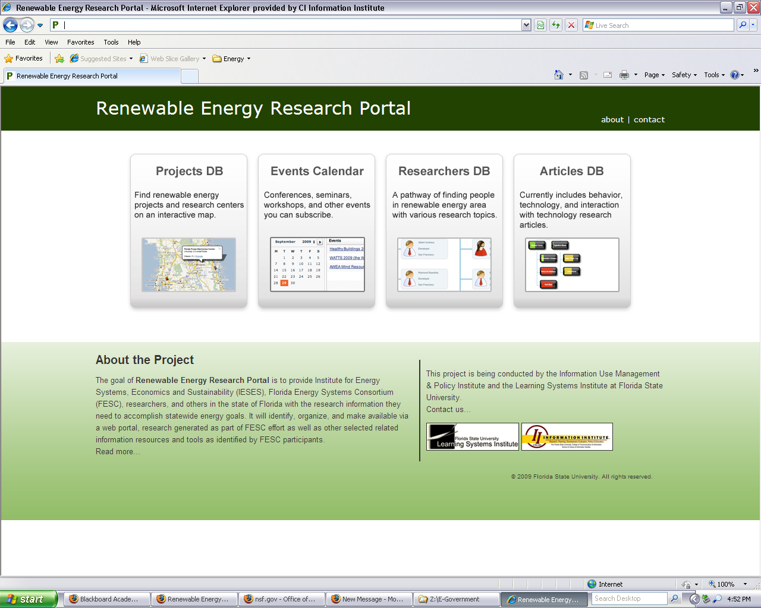

Figure 1. The Renewable Energy Website

______________________________________________________________________________

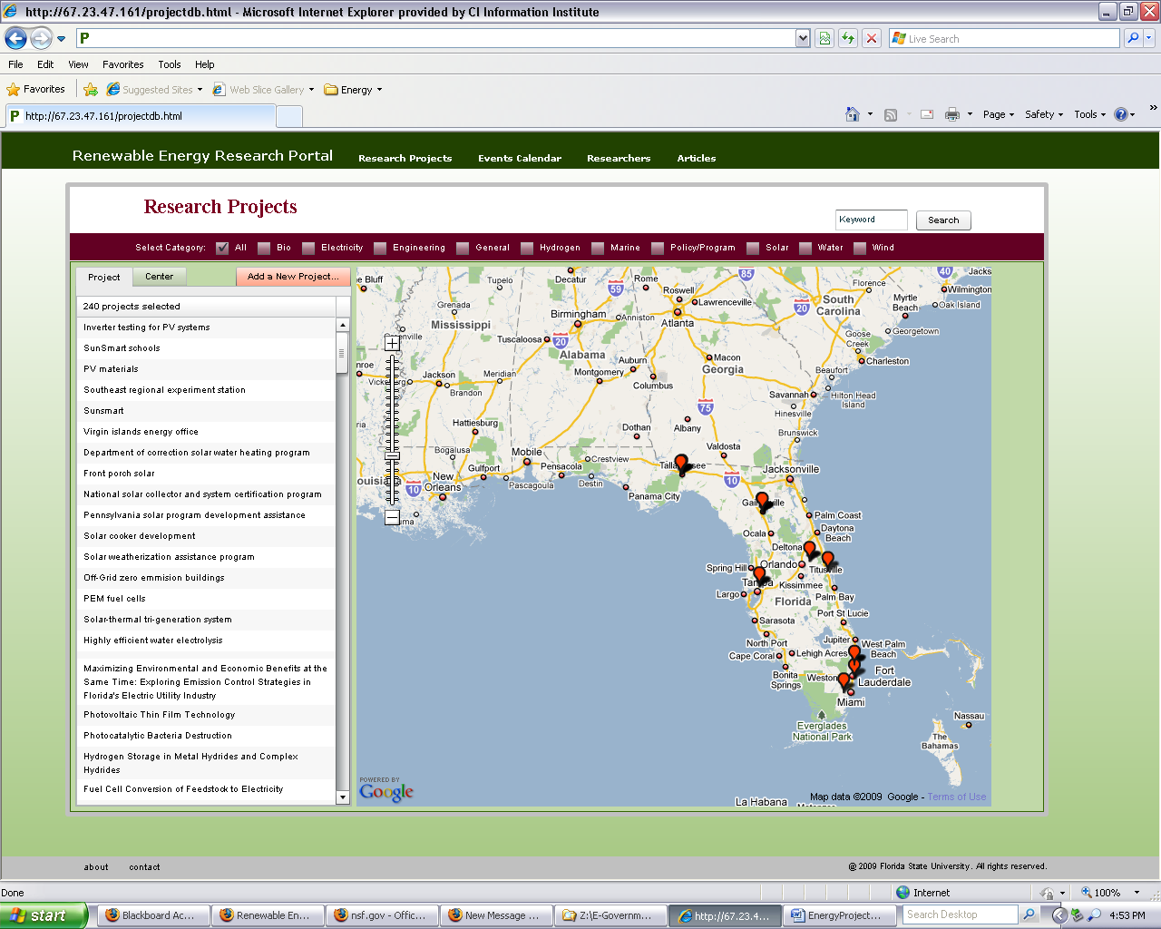

Figure 2. The Projects Database

______________________________________________________________________________

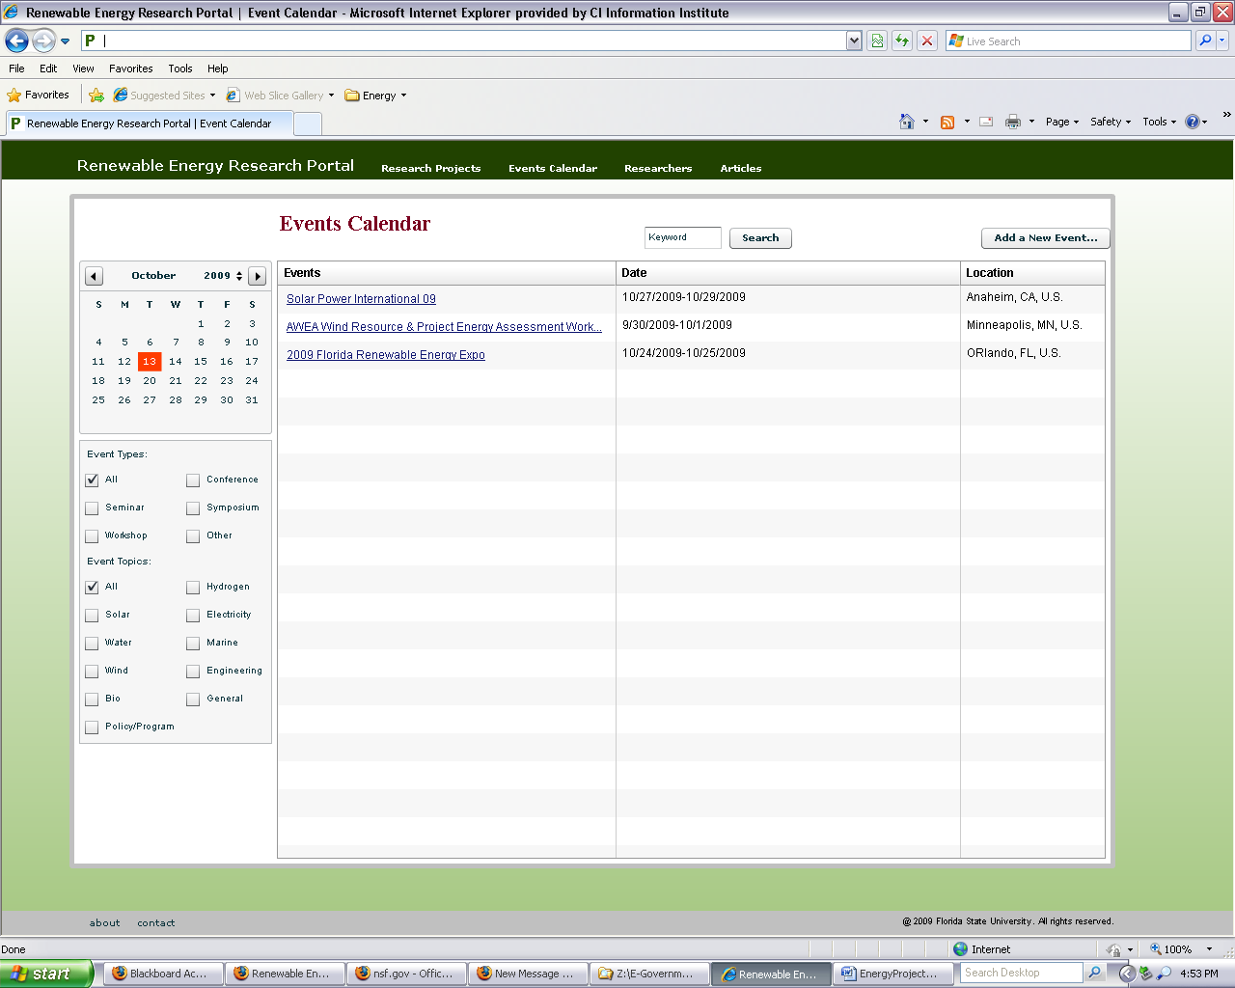

Figure 3. The Events Calendar

______________________________________________________________________________

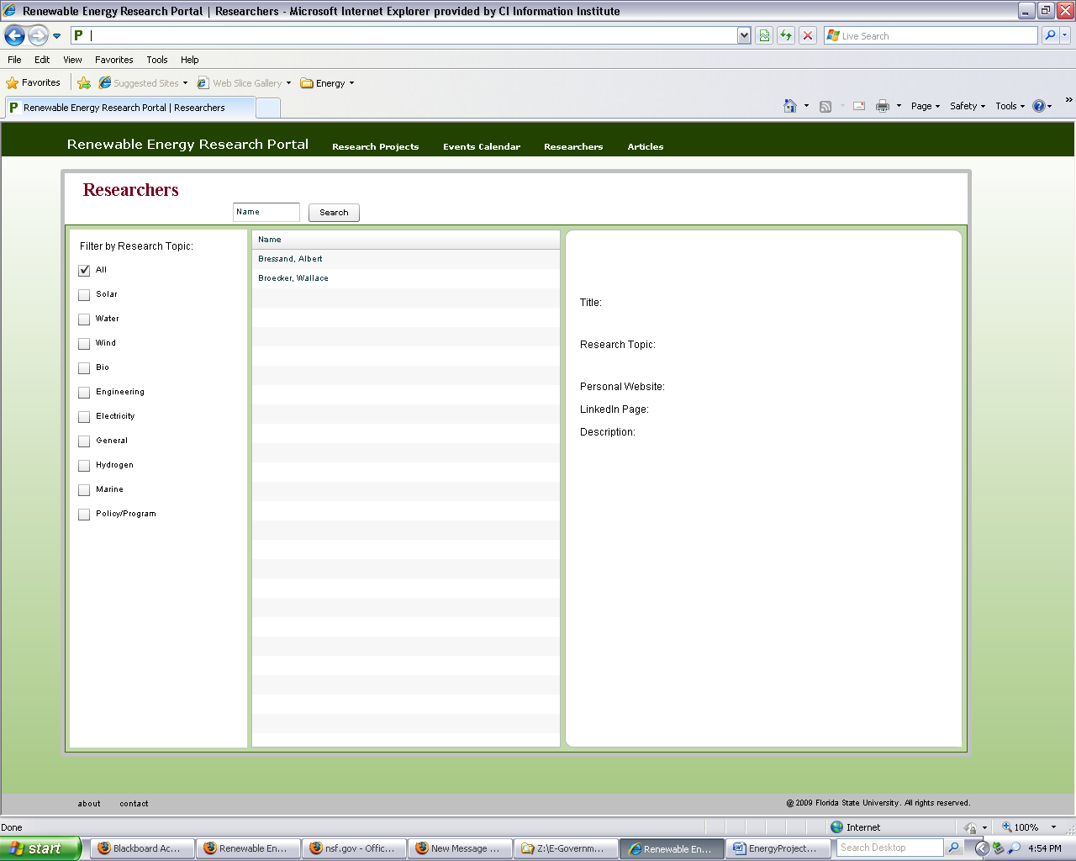

Figure 4. The Researchers Database

______________________________________________________________________________

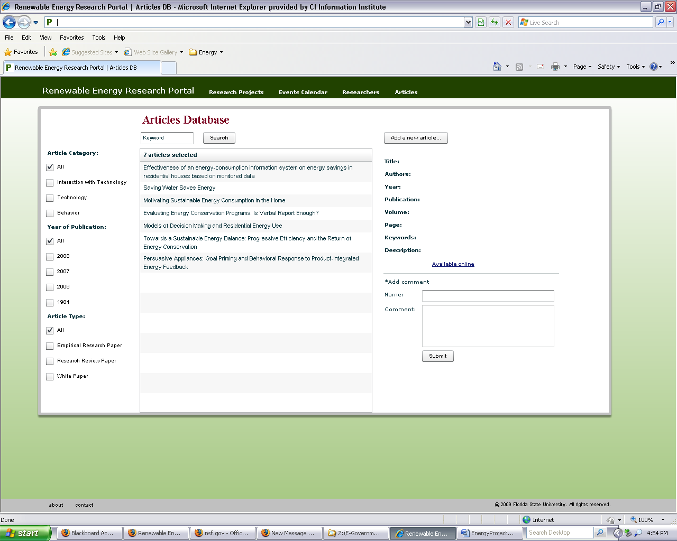

Figure 5. The Articles Database

______________________________________________________________________________