LSSI Virtual Reference Toolkit

Statistical Capabilities of VRT Software…and a glimpse of what the Web Reference Center is doing with our data

- A variety of report options available quickly and easily within software.
- Reports by librarian, by client, by date, by time, by queue, by referring URL (e.g. page on which client enters VR service), IP of client, etc.
- Information available about total and average length of call, cal start and end times, hold times, abandoned times, minimum and maximum values for a variety of fields. Links to session transcripts included in reports.
- Output format includes HTML and allows for comma delimited exporting for additional manipulation
- Reports may be run by a librarian with Administrator privileges and are quick and easy—results in seconds in a clear, easy to read format

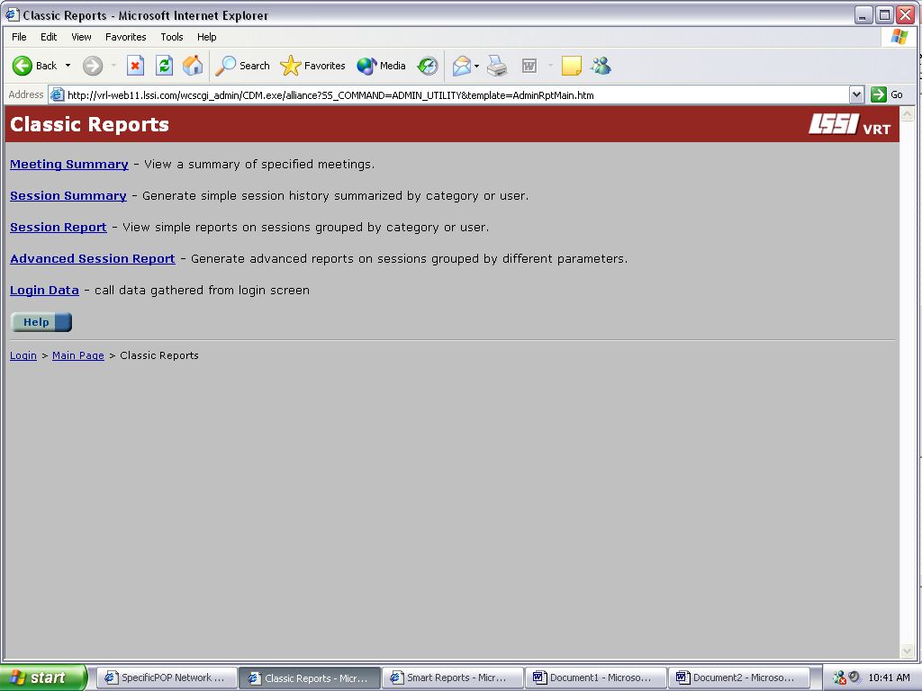

Reporting Options
Session Report Screen: Search options are limited for quick reports, which provide an overview of service—choices include dates and times. Sorting is by Librarian, queue, or IP address.

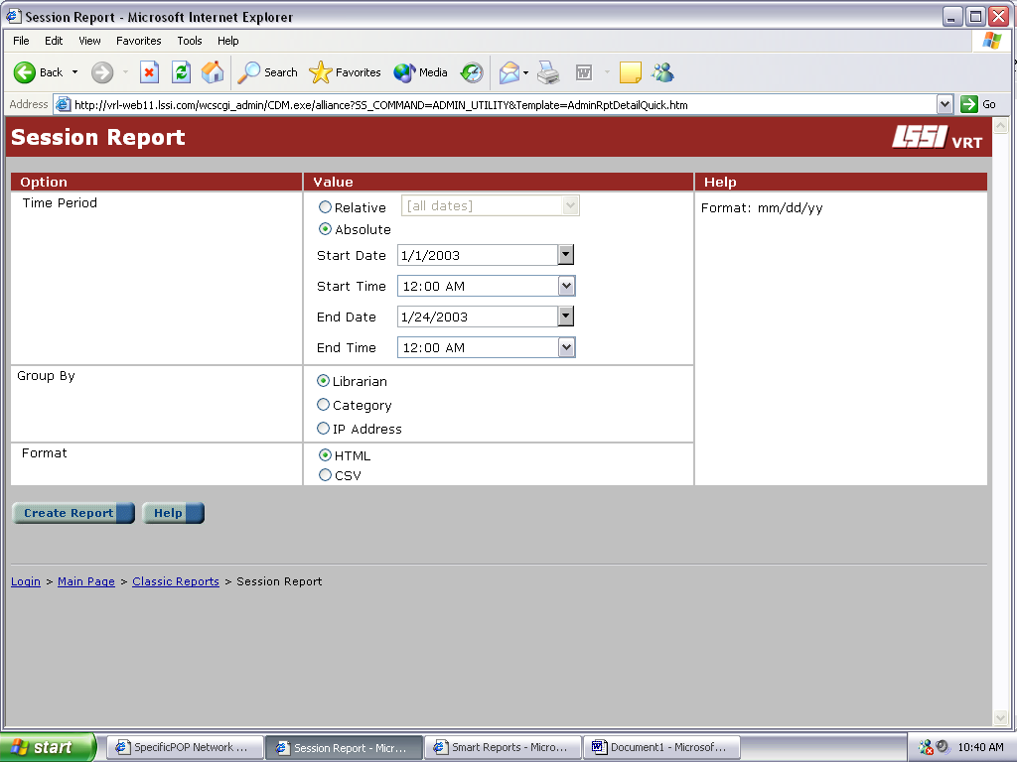

Advanced Session Report Screen: Provides a wider variety of criteria on which to run reports. Includes parameters as for Session Reports, but also includes User Name (librarian), Call Resolution, Category, Patron ID, Closed by, and Customer IP. Group by options are also more extensive.
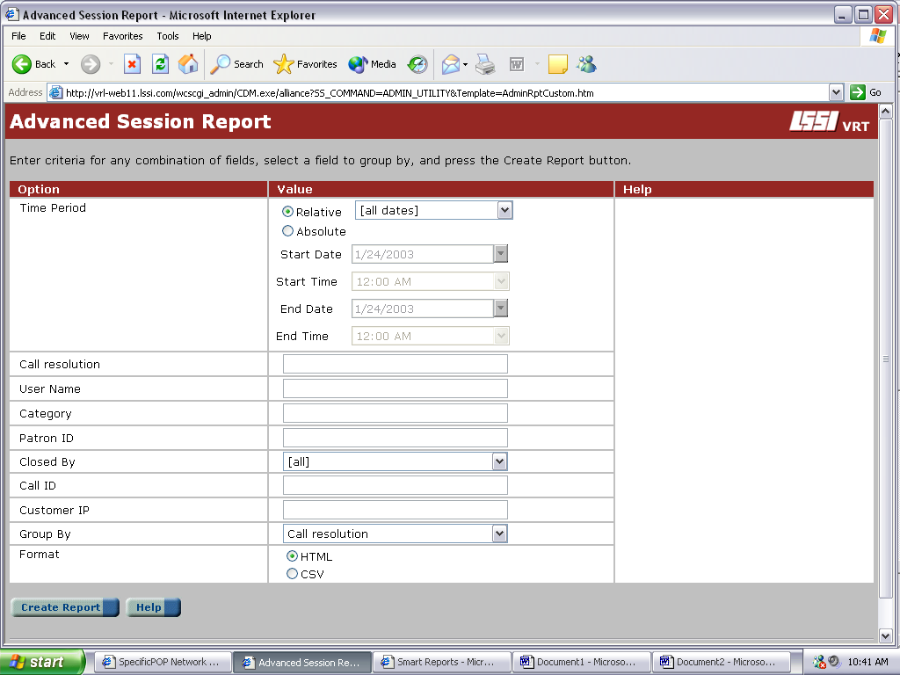

Report. Top level display: Call ID is a unique identifier linking to the transcript; Customer ID is patron’s email address or name; Rep ID is librarian’s login ID. 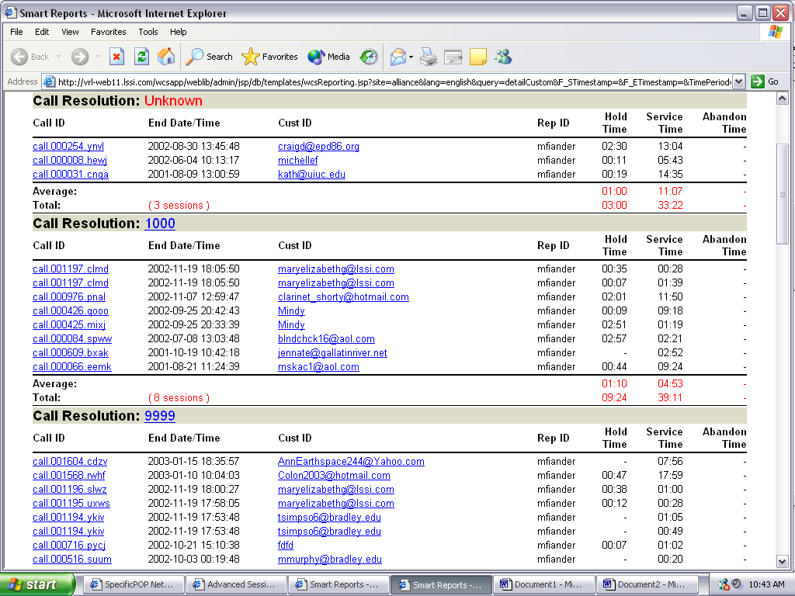

Christmas
Holidays

Web Reference Center: Number of Calls Per Day

Number of Calls Per Hour

