ALA Midwinter – 2003

POLARIS ™ is currently installed in over 200 libraries in the United States. Polaris Release 3.0 is currently being Beta tested in the field by the Washington County Library Consortium, a multi-library consortium of over 20 libraries.

Polaris offers a variety of on demand reports that can be run from the staff workstations in window such as that below. Customized reports are also be generated by querying the Polaris database using SQL and exporting the data to Crystal.

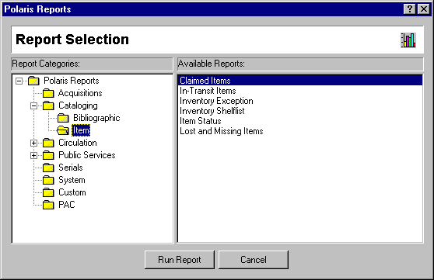

Beginning with Release 3.0, Gaylord used Z39.7 Library Statistics Data Dictionary to help us further define data that the system collects for reports desired by public libraries. We continue to consult Z39.7 as new reports are added to Polaris.

Amongst the statistics available in Polaris, the following may have some interest to the committee:

Polaris Z39.7 equivalent
Statistical overview (includes)
Counts of
Bibliographic records Books and Serials holdings
Authority Control Records
Item Records Books and Serials holdings – physical units
Active Patrons Registered Library User
Records added Year to date
Bibliographic Records Books and Serials Additions
Authority Control Records
Item Records Books and serials additions - volumes
Active Patrons
PAC statistics year to date
Browse searches
Keyword searches
Phrase searches
Power searches
Search assistant invocations
Virtual Reference sessions invoked (3.0) Virtual Reference Transactions

Resource Sharing (samples provided)
Circulations by Item’s assigned Branch Materials provided to other libraries Patron Cross Borrowing Materials obtained from other libraries

Current Serials Received (future) Current Serials Received

