H. W. Wilson Company Usage Statistics for WilsonWeb
Home Page: www.hwwilson.com - Documentation
Bernie Seiler – Product Manager, WilsonWeb
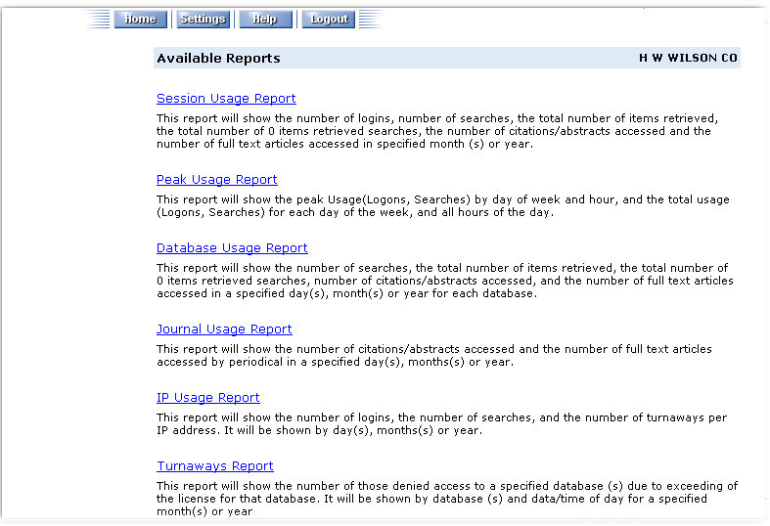

Example: Report request screen
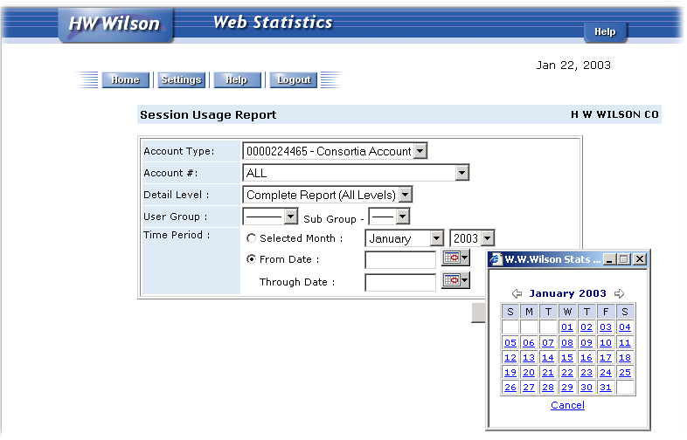
Example: Session usage report
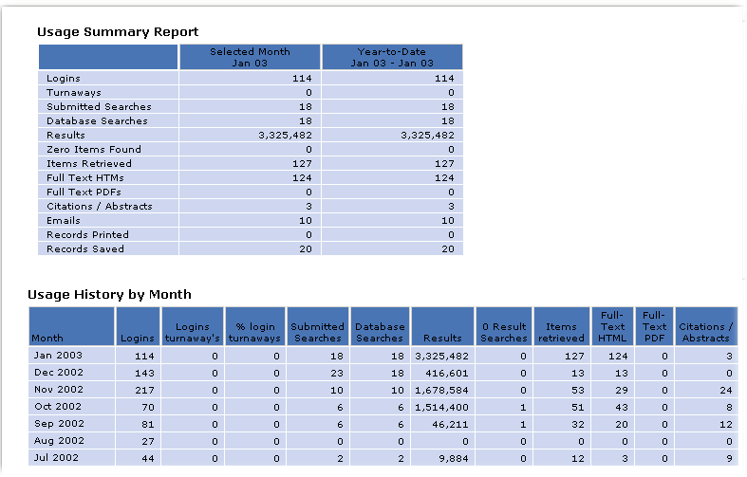

Example: Peak usage report
